InControl

Installation Manual

|  |  |  |
| --- | --- | --- |
| Version | Date | Writer |
| 1.0 R1 | 1-2-2017 | CBA |
| 1.0 R2 | 1-2-2017 | DR |

|  |
| --- |
| Contents |

1 Introduction 4

1.1 Components 4

1.1.1 InControl OPC Service 4

1.1.2 InControl SQL Service 4

1.1.3 InControl GUI 4

2 InControl OPC Service 5

2.1 Prerequisites 5

2.2 Installation 5

2.3 Start the Service 14

3 InControl SQL Service 15

3.1 Prerequisites 15

3.2 Installation 15

3.3 Start the Service 35

3.4 Implement the License 36

4 InControl User Interface 37

4.1 Prerequisites 37

4.2 Installation 37

4.3 Check if everything is up and running 44

5 Troubleshooting 46

5.1.1 Can’t find ‘InControl OPC Service’ in the list with services 46

5.1.2 ‘InControl OPC Service’ failed to start. 46

5.1.3 Can’t find ‘InControl SQL Service’ in the list with services 46

5.1.4 ‘InControl SQL Service’ failed to start. 46

5.1.5 ‘InControl SQL Service’ has stopped working. Unable to load DLL ‘websocket.dll’ 47

5.1.6 ‘InControl SQL Service’ SQL error: Connect => Cannot open database “InControl” requested by the login. 48

5.1.7 No License Found 48

5.1.8 Invalid License 48

# Introduction

This manual describes the installation process, needed to install the InControl application.

## Components

There are 3 components that need to be installed/configured for the application to work.

### InControl OPC Service

This is a background service that is responsible for the OPC connection with the OPC server. It will monitor the configured data in DCS system and sent its information to the SQL Service

**Installation Location:** needs to be installed on a computer in the DCS network which has permission to connect to the OPC server.

### InControl SQL Service

This is a background service that is responsible for the SQL Connection with the SQL server. This service communicates with the OPC service and processes the received data.

**Installation Location:** needs to be installed on a computer that has a SQL server installed or can be installed, and that can communicate with the computer where the OPC Service is installed.

### InControl GUI

The GUI is the visual part of the application. The GUI will communicate with the SQL Service and will display the bypass status and information..

**Installation Location:** needs to be installed on a computer that can communicate with the computer where the SQL Service is installed.

# InControl OPC Service

The “InControl OPC Service” is a background service that is responsible for the OPC connection with the OPC server. This service will monitor the configured modules and sent its values to the “InControl SQL service” where those values will be processed.

## Prerequisites

Visual C++ redistributable for Visual Studio 2015 (included in the OPC service installer)

## Installation

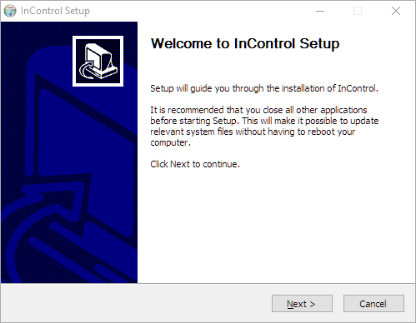

To install the “InControl OPC Service”. Start the “**InControl-installer.exe**” and click on Next.

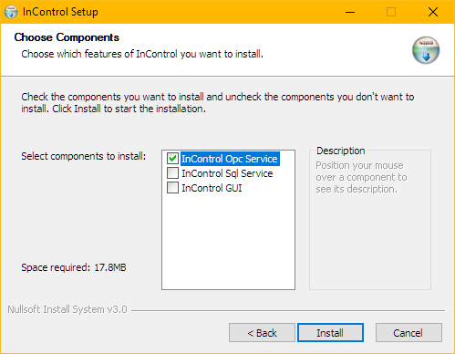

Deselect both “InControl SQL Service” and “InControl GUI” so that only “InControl OPC Service” is selected and press on Install.

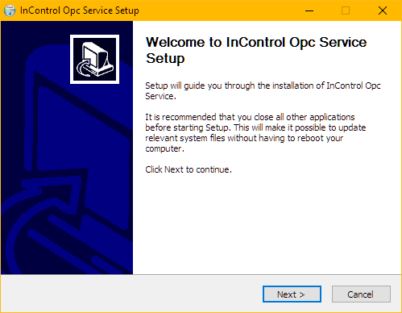

Press Next.

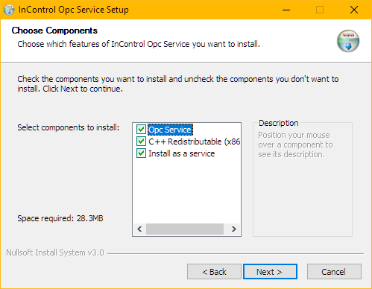

Choose which components needs to be installed.

* **OPCService:** install the tools that is communicating with the OPC Server.
* **C++ Redistributable (x86):** If this is not yet installed on the system, selecting this component will install it. Note that this is necessary for the OPC Service to work.
* **Install as a service:** Will install the OPC Service as a windows service. By doing this it will run silently on the background.

Press Next.

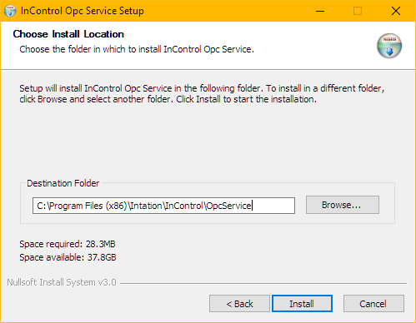

Select what you want to use as the installation folder. The default location is “C:\Program Files\Intation\InControl\OPCService”

Press Install.

If you have selected to install “C++ Redistributable 2015” press “I agree to the license terms and conditions” and press “Install”.

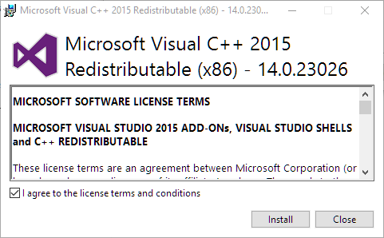

If you selected that you want to install as a service the following window will pop up, prompting the user for a username and password.

This is the user account the service will use to execute.

The username needs to look like this **“COMPUTERNAME\USER”**

Example: “COMPUTER01\Administrator”

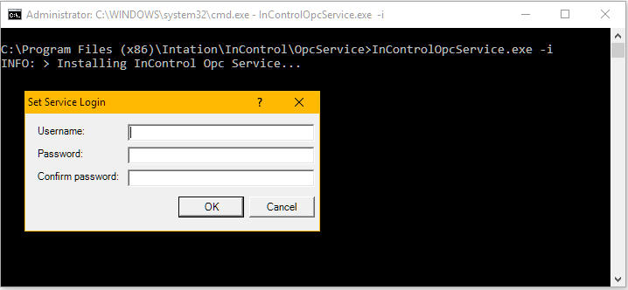

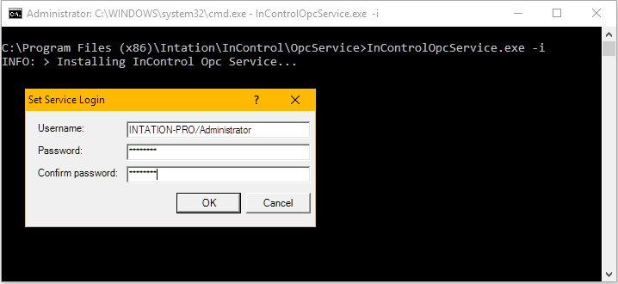

After the installation is complete, you will need to configure the service and tell it what parameters it needs to use.

* **OPC server:** this is the name of the OPC server you are going to use. If you are using this tool in a DeltaV environment this is: **OPC.DeltaV.1**
* **Maximum OPC tags:** the number you fill in here tells the service how many tags it may maximum use to read out data from the OPC server.

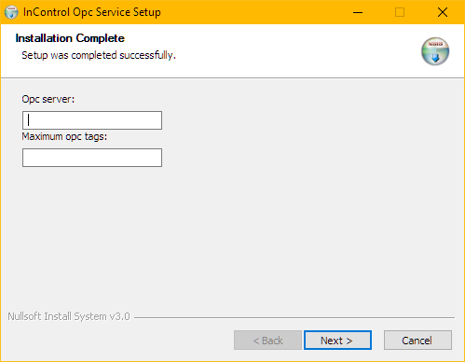

Press Next

Example:

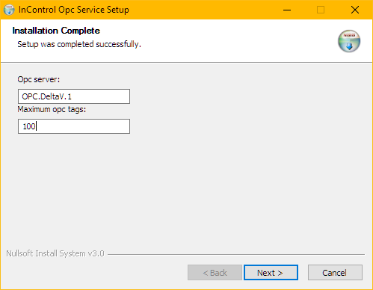

After this, the installation should be finished and the following window should pop up. Press finish the close the installation.

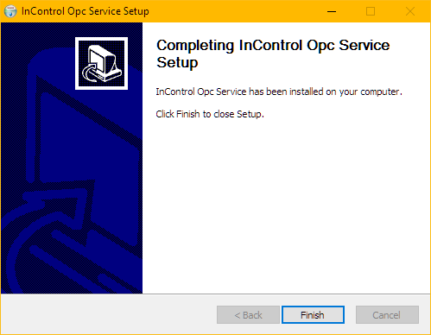

## Start the Service

To start the “InControl OPC Service” go to “Services”. This can be found in “Start -> Administrative Tools -> Services”.

Look for a service called “InControl OPC Service” right click on it and press start.

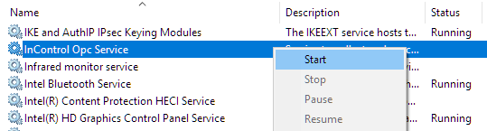

The service is now starting and the status should change to “Started” or “Running”

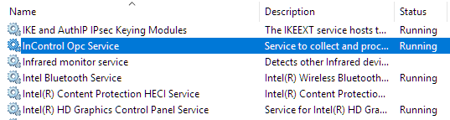

# InControl SQL Service

The “InControl SQL Service” is a background service that is responsible for the connection to the SQL Database. This service will process all the data it received.

## Prerequisites

Visual C++ redistributable for Visual Studio 2015

Microsoft .NET Framework 3.5 SP1

Microsoft .NET Framework 4.5.2

## Installation



To install the “InControl SQL Service”. Start the “**InControl-installer.exe**” and click on Next.

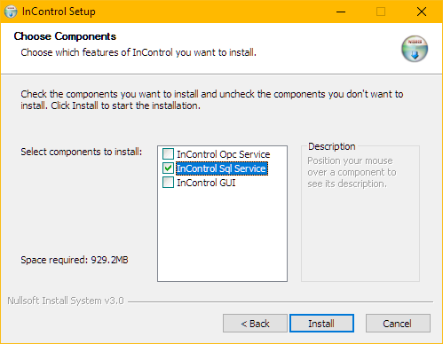

Deselect both “InControl OPC Service” and “InControl GUI” so that only “InControl SQL Service” is selected and press on Install.

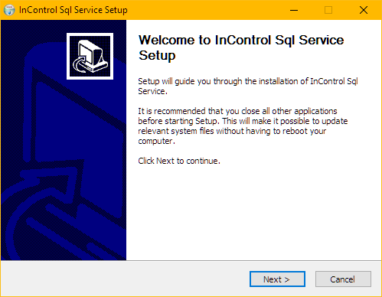

Press Next.

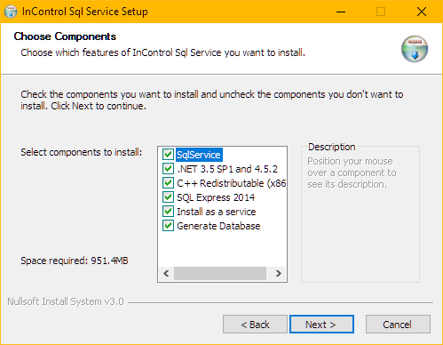

Choose which components needs to be installed.

* **SQLService:** install the tools that is communicating with the OPC Server.
* **.NET 3.5 SP1 and 4.5.2:** this will install both dot netversions that are needed
* **C++ Redistributable (x86):** If this is not yet installed on the system, selecting this component will install it. Note that this is necessary for the OPCService to work.
* **SQL Express 2014:** Will install SQL Express 2014 that is used to store data.
* **Install as a service:** Will install the OPCService as a windows service. By doing this it will run silently on the background.
* **Generate Database:**  This will generate the database that is used by SQLService.

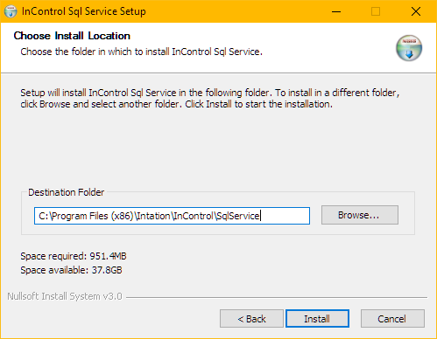

Select what you want to use as the installation folder. The default location is “C:\Program Files\Intation\InControl\SQLService”

Press Install.

If you have selected to install “C++ Redistributable 2015” press “I agree to the license terms and conditions” and press “Install”.



If you have selected to install SQL Express 2014. Leave the directory as default and press Ok.

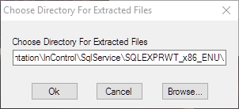

SQL Express 2014 will now prepare the installation.

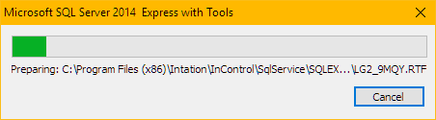

When the “SQL Server Installation Center” opens. Select “New SQL Server stand-alone installation.”

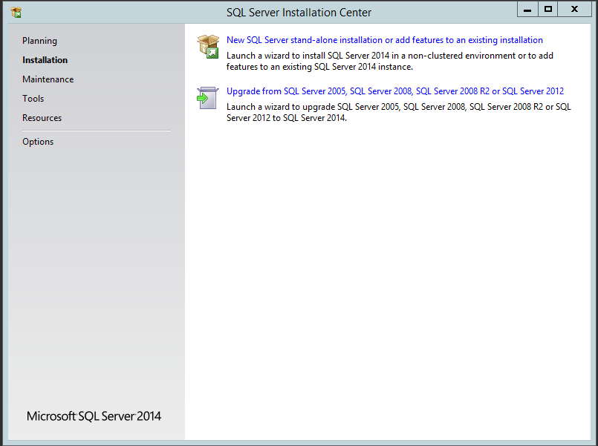

Click on “I accept the license terms” and then click on “Next”.

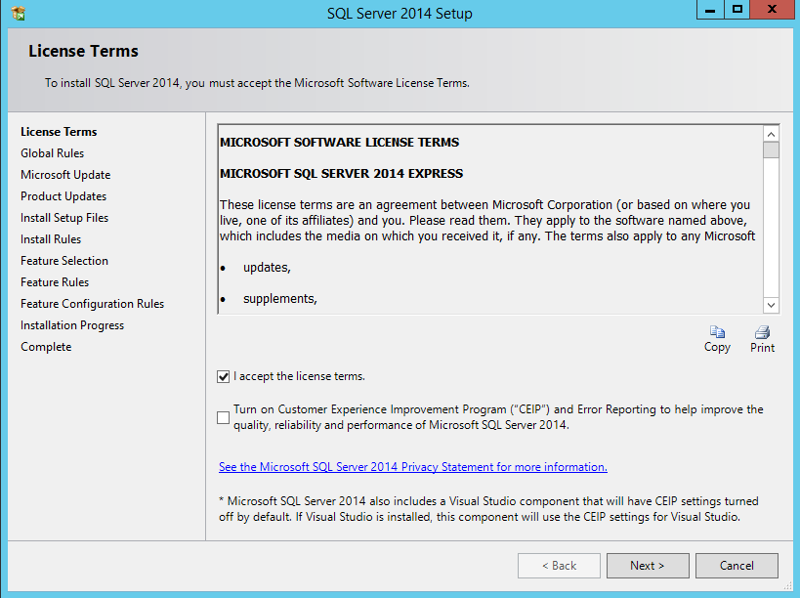

Click on “Next”.

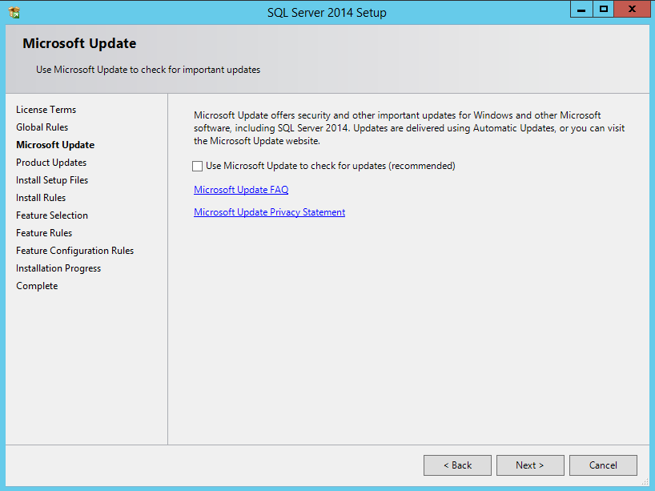

Click on “Select all” and then on “Next”.

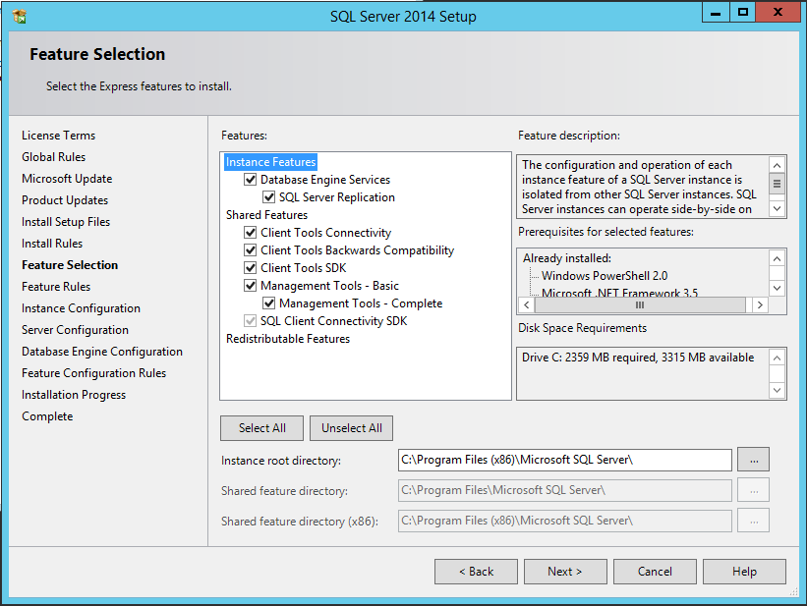

Leave the Instance name as “SQLExpress” and the Instance ID “SQLEXPRESS”. These names will later be used in the database creation.

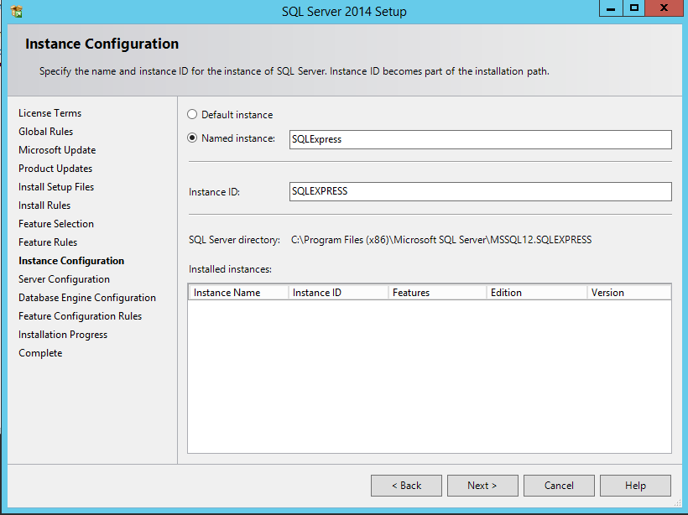

Click on “Next”

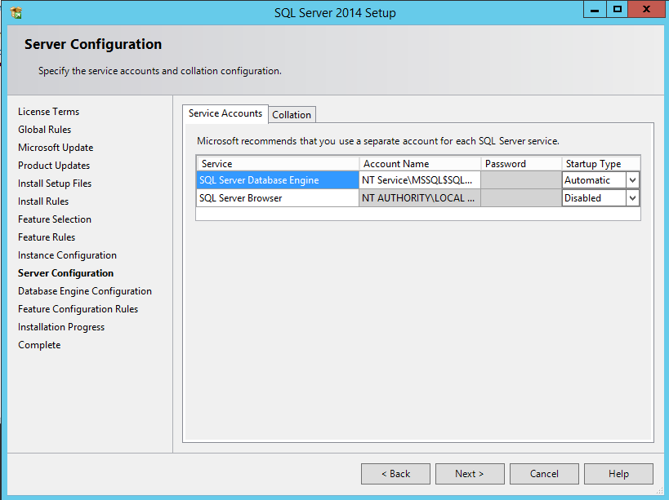

Select what user you want to be Server administrator, default this is the user you are logged in with. Then click on “Next”.

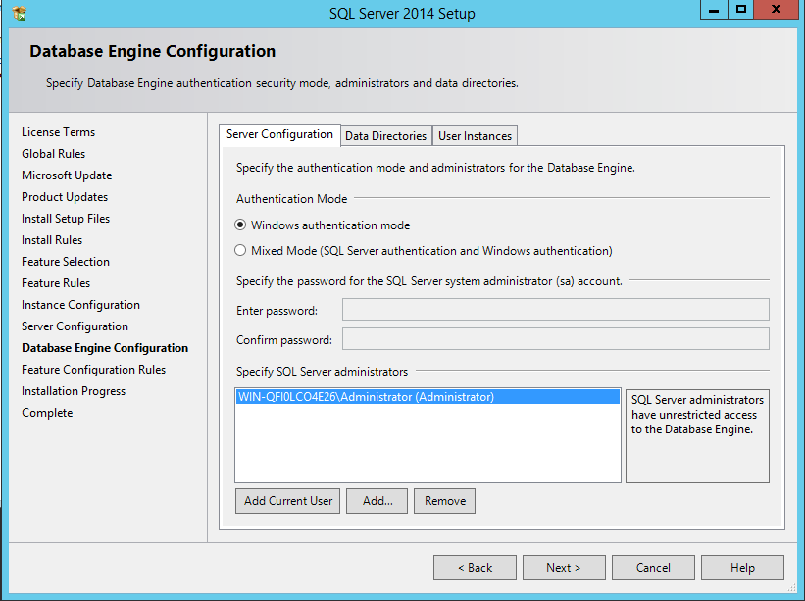

The installation is now in progress.

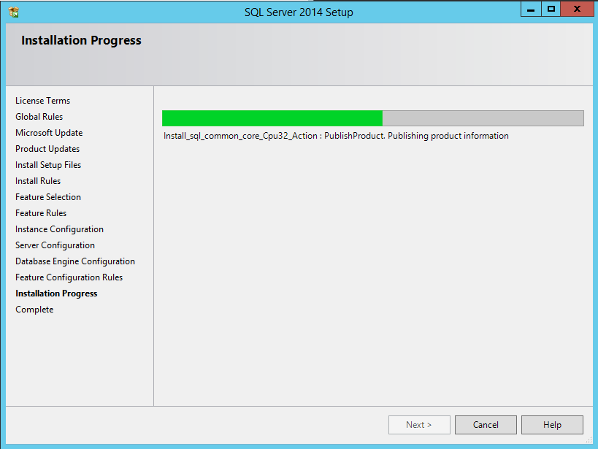

After the installation is finished you should see the following window. Click on “Close”

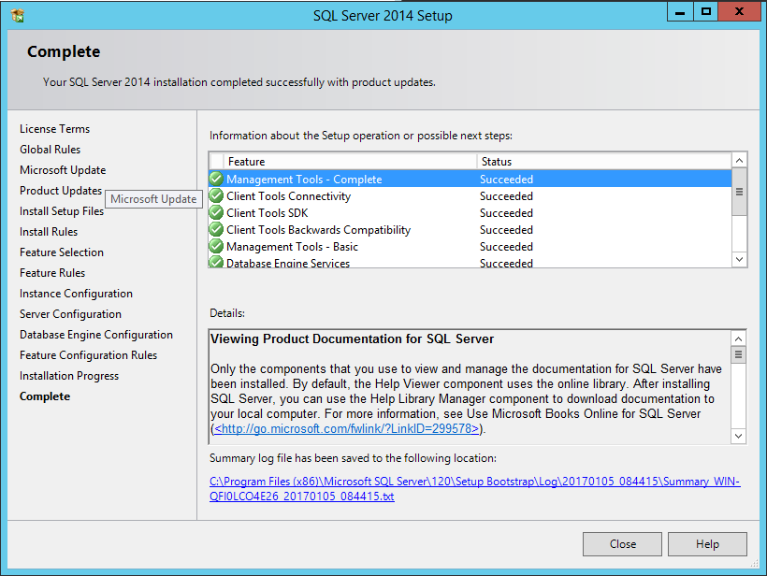

You can now close the “SQL Server Installation Center”

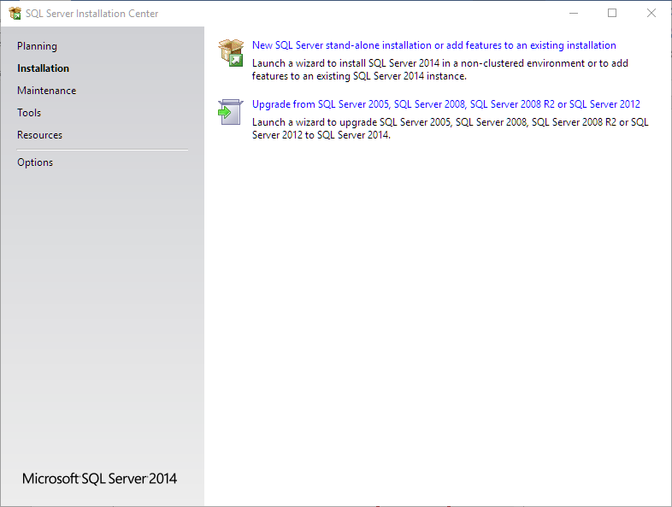

After the installation is complete, you will need to configure the service and tell it what parameters it needs to use.

* **InControl OPC Service IP Address:** this is the IP Address of the computer where you installed the “InControl OPC Service”.
* **OPC server:** this is the name of the OPC server you are going to use. If you are using this tool in a DeltaV environment this is: **OPC.DeltaV.1**
* **SQL Servername:** This is the name of the SQL server. If you followed the above steps the default servername is “***COMPUTERNAME*\SQLEXPRESS**”

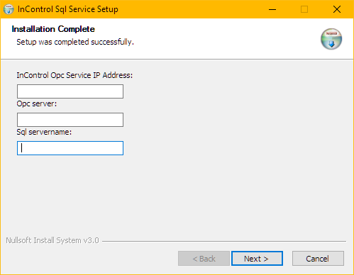

Press Next

Example:

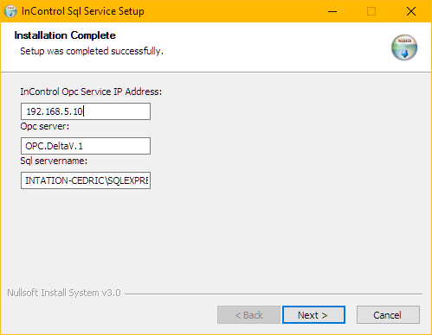

## Start the Service

To start the InControl SQL Service go to “Services”. This can be found in “Start -> Administrative Tools -> Services”.

Look for a service called “InControl SQL Service” right click on it and press start.

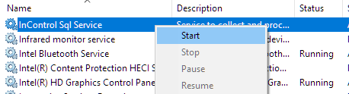

The service is now starting and the status should change to “Started” or “Running”

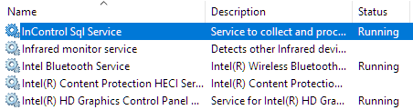

## Implement the License

To have full functionality a license file need to be imported. This license file is delivered by Intation.

This license file is used by the SQLService, thus needs to be placed in the following directory “C:\Program Files\Intation\InControl\SQLService”

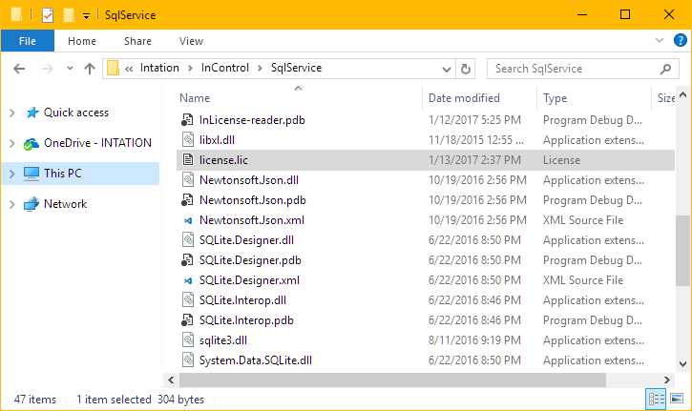

# InControl User Interface

The “InControl User Interface” is visual part of the application. The GUI will communicate with the background SQL Service and will display the active bypasses.

## Prerequisites

Visual C++ redistributable for Visual Studio 2015

Microsoft .NET Framework 4.5.2

## Installation



To install the “InControl OPC Service”. Start the “**InControl-installer.exe**” and click on Next.

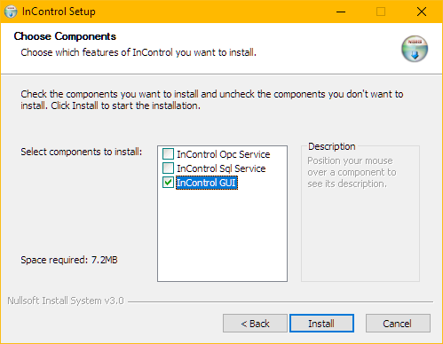

Deselect both “InControl SQL Service” and “InControl OPC Service” so that only “InControl GUI” is selected and press on Install.

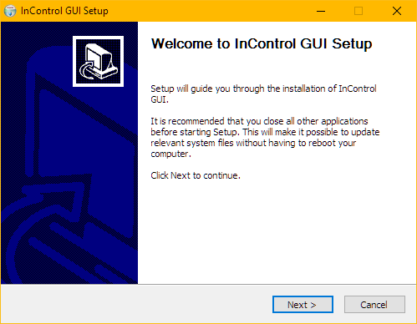

Press Next.

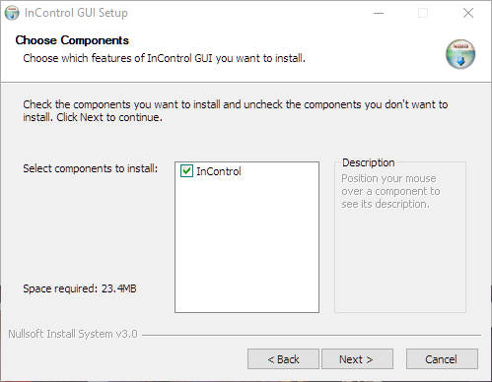

Choose which components needs to be installed.

* **InControl:** Install the GUI for the InControl application.

Press Next.

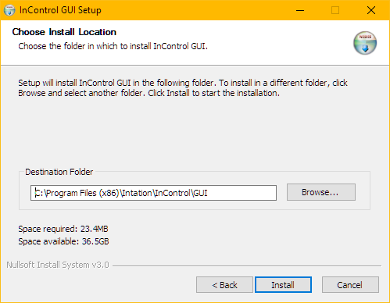

Select what you want to use as the installation folder. The default location is “C:\Program Files\Intation\InControl\GUI”

Press Install.

After the installation is complete, you need to configure what OPC server you want to use, and what your maximum OPC tags you want to use.

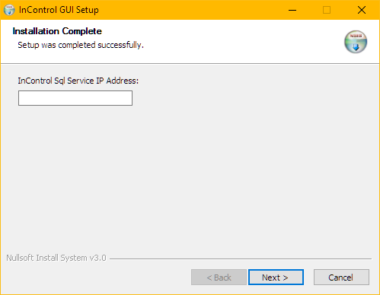

Press Next

Example:

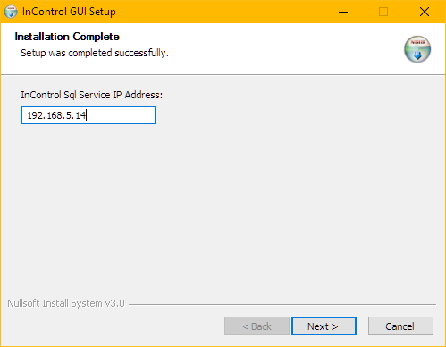

## Check if everything is up and running

To check if everything is configured correctly and all everything is communicating with each other open the InControl GUI. Go to “C:\Program Files (x86)\Intation\InControl\GUI” and double-click on “InControl.exe”

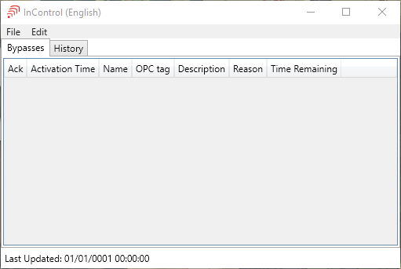

To check the status go the notification bar in the right bottom corner and left click on the InControl Logo



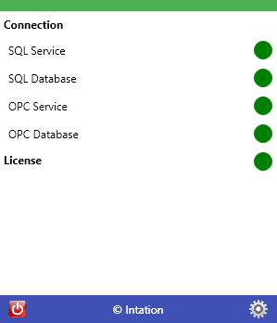

All status indicators should be green. This means that a connection is established end that the tool is working as intended.

# Troubleshooting

### Can’t find ‘InControl OPC Service’ in the list with services

Make sure the service is installed. You can manually install it by going to “C:\Program Files\Intation\OPCService\tools” and double-clicking on “install_service.bat” or rerun the installer.

### ‘InControl OPC Service’ failed to start.

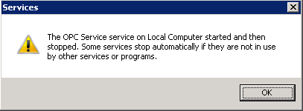

Make sure the **C++ Redistributable (x86)** is installed. To install it rerun the installer and check it during the component window.

### Can’t find ‘InControl SQL Service’ in the list with services

Make sure the service is installed. You can manually install it by going to “C:\Program Files\Intation\SQLService\tools” and double-clicking on “install_service.bat” or rerun the installer.

### ‘InControl SQL Service’ failed to start.

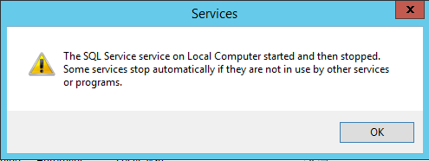

Make sure the **C++ Redistributable (x86)** is installed. To install it rerun the installer and check it during the component window.

### ‘InControl SQL Service’ has stopped working. Unable to load DLL ‘websocket.dll’

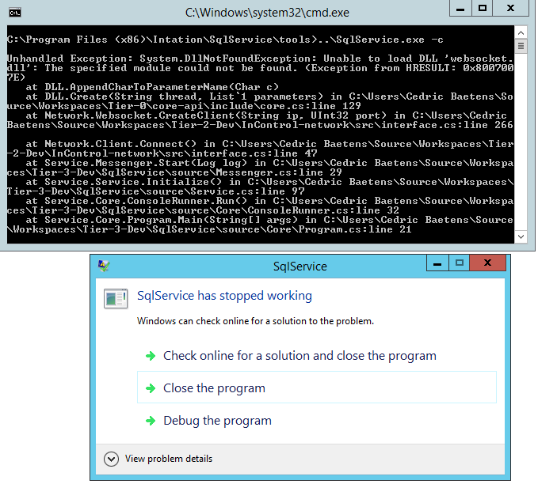

Make sure the **C++ Redistributable (x86)** is installed. To install it rerun the installer and check it during the component window.

### ‘InControl SQL Service’ SQL error: Connect => Cannot open database “InControl” requested by the login.

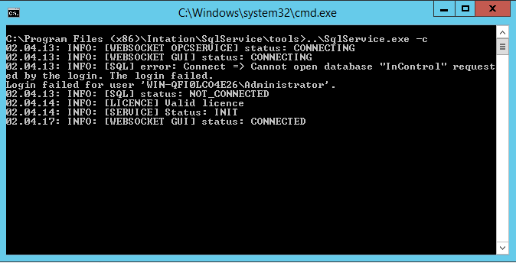

Make sure the database “InControl” is created on the SQL server. To create this database go to “C:\Program Files (x86)\Intation\SQLService\tools” and double-click on “databasecreation.bat”

### No License Found

Make sure you have copied the file “license.lic” to the right location. Check point 2.5 in this document to resolve this issue.

### Invalid License

This means that the license you are trying to use not valid. Make sure you have the right license file.